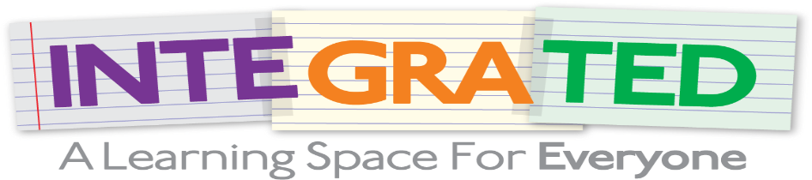
Integrated: Challenges and opportunities of integrating third-country national children in the education system
https://www.integrated-project.eu/

PARTNER’S LOGO
The challenges and opportunities of integrating third-country national children in the education system during the COVID-19 pandemic were discussed in the online stakeholder meeting of the European funded project “Integrated: Promoting Meaningful Integration of 3rd Country National Children to Education”, which took place on the 20th of October.
More than 70 educators, representatives of educational authorities and members of civil society organisations participated in the event that was originally scheduled to take place in Brussels, but was finally held online due to COVID-19 restrictions.
During the event, participants discussed the outputs of the project in Greece, Italy and Spain, including its pilot implementation in 13 intercultural schools, which adopted the mentor and mentee program in the school curriculum. In this framework, the project partners presented the results and their recommendations regarding the needs of education for newly arrived third-country national students.
Additionally, participants had the chance to talk about the “IntegratEd” e-learning platform that was developed during the project with the aim to support the academic performance of third country national students. The COVID-19 outbreak has led to dramatic changes in education and the rise of e-learning platforms. With this sudden shift away from the classroom, the IntegratEd platform has proved an effective way for third-country national children to learn and grow via e-learning.
You can watch our video about the platform
👉 https://www.youtube.com/watch?v=mQImNf3SvxQ
About the project
The project “Integrated: Promoting Meaningful Integration of 3rd Country National Children to Education” aims to strengthen the successful participation of newly arrived third-country national children in education and to contribute to the combatting of discrimination against third-country national children in the educational environment in Greece, Italy & Spain, and the EU in general.
The project is funded by AMIF and is implemented in Greece, Italy and Spain.
Find out more about the project 👉 https://www.integrated-project.eu/.
For more information, contact us at PARTNER’S EMAIL.

